***Experiment 4 Output***

**Aim:** This experiment focuses on configuring and managing cloud networking services, such as creating Virtual Private Clouds (VPCs) and subnets. It involves using cloud platforms like AWS, Google Cloud, or Azure to set up and manage cloud networking environments.

***Creating Subnet and API Gateway***

***Starting VPC***

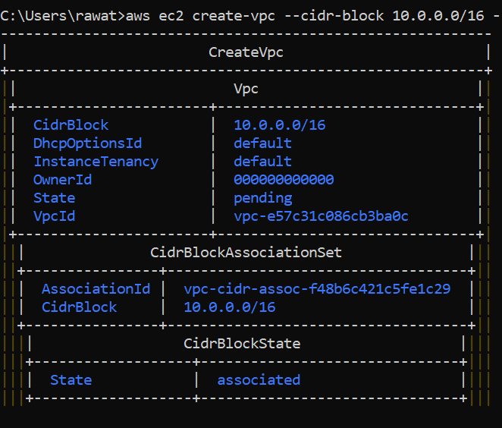

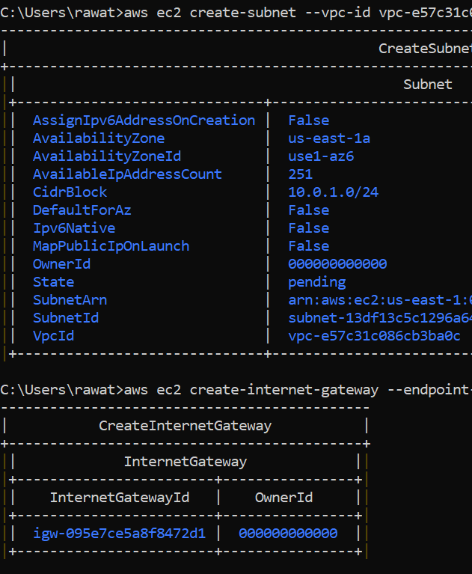

***Fig 2: Subnet and API Gateway Setup***

**Fig 1: VPC Setup**

***Creating a Route Table***

***Listing Subnets and Connections***

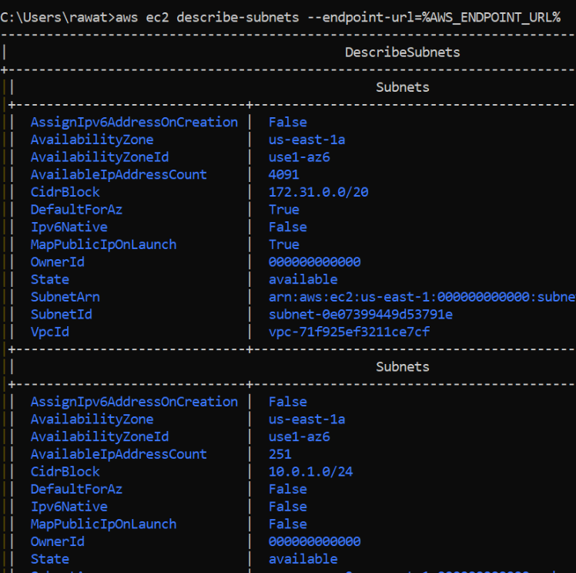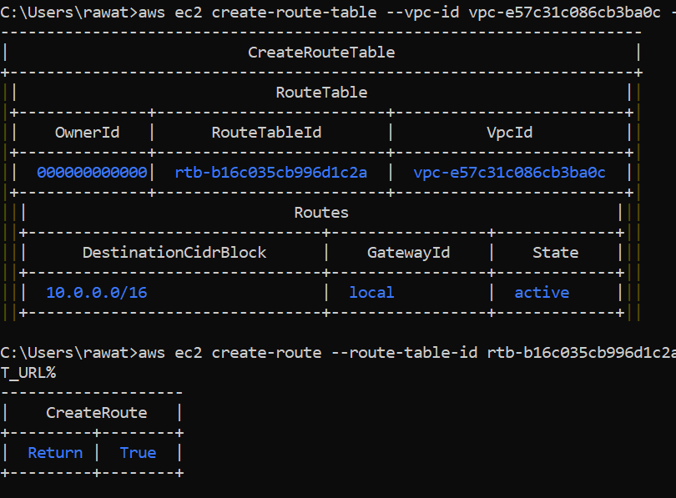

***Fig 3: Route Table and Creating new Routes***

***Fig 4: List of Subnets***